**RPL OBJECTIVE FUNCTION**

**Software Requirements:**

Operating System : Ubuntu 14.04 LTS 64bit, Vmware Player 16.1.0, Instant contiki-3.0 Simulator: Cooja

Language : C

**Simulation Model:**

|  |  |
| --- | --- |
| Simulator | Cooja |
| Number of Nodes | 25,50 nodes. |
| Routing Protocol | RPL protocol |
| Transmission Range | 50m |
| Area | 300m * 300m |
| Simulation Time | 300 seconds |
| Objective function | MRHOF,OF0 |
| Radio Medium Model | UDGM-distance loss |
| Mote Type | Sky |
| Topology | Random |

**Network model:**

**Topology:** Random topology

**Total Simulation time**: 300 seconds

* **Server** **node**
* **Client node**

**No.of.Nodes25**

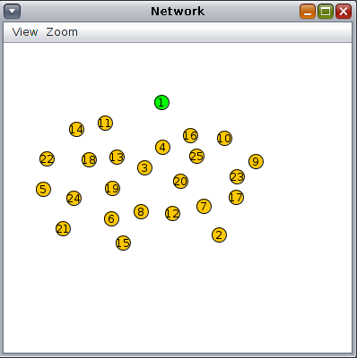

**No.of.Nodes50**

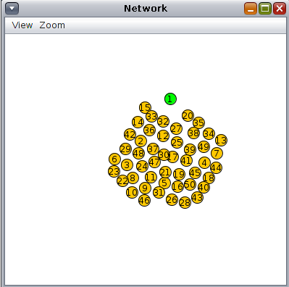

**Simulation**

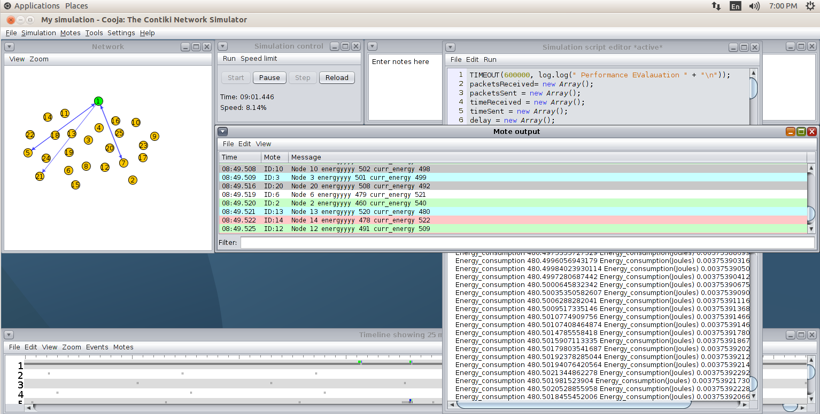Each RPL node has its predefined objective function (OF), this function carries the metrics upon which nodes select the better parent among competing nodes. There are currently two objective functions presented by the IETF, the first one is Objective Function zero (OF0).The second and the more popular one is the minimum rank with hysteresis objective function (MRHOF).

**Screenshots Explanation:**

**ENERGY CALCULATION(tcpip.c)**

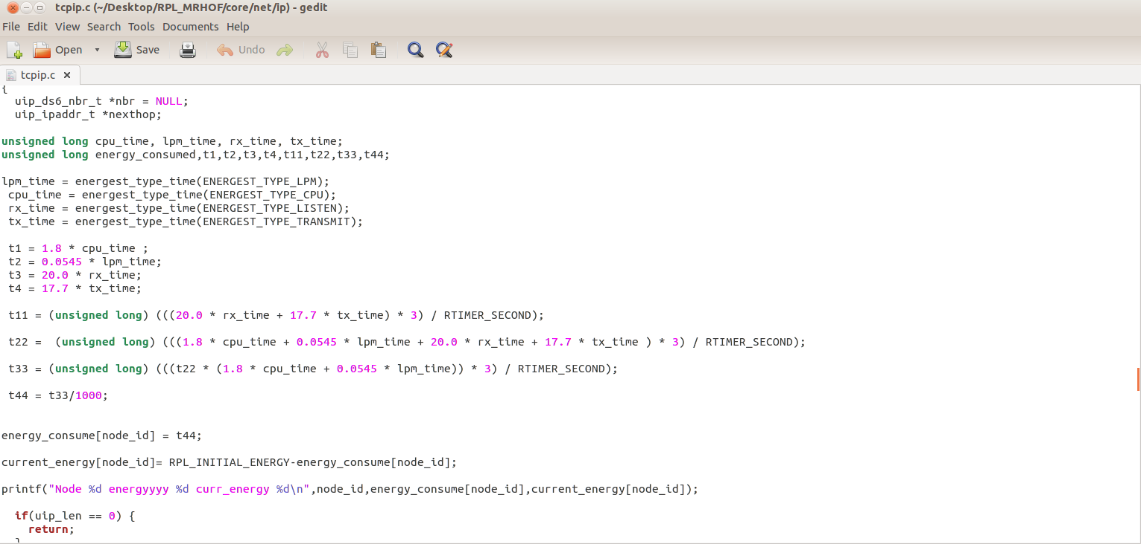**DATA SEND(udp-client.c)**

Each client node send data packets to the server.

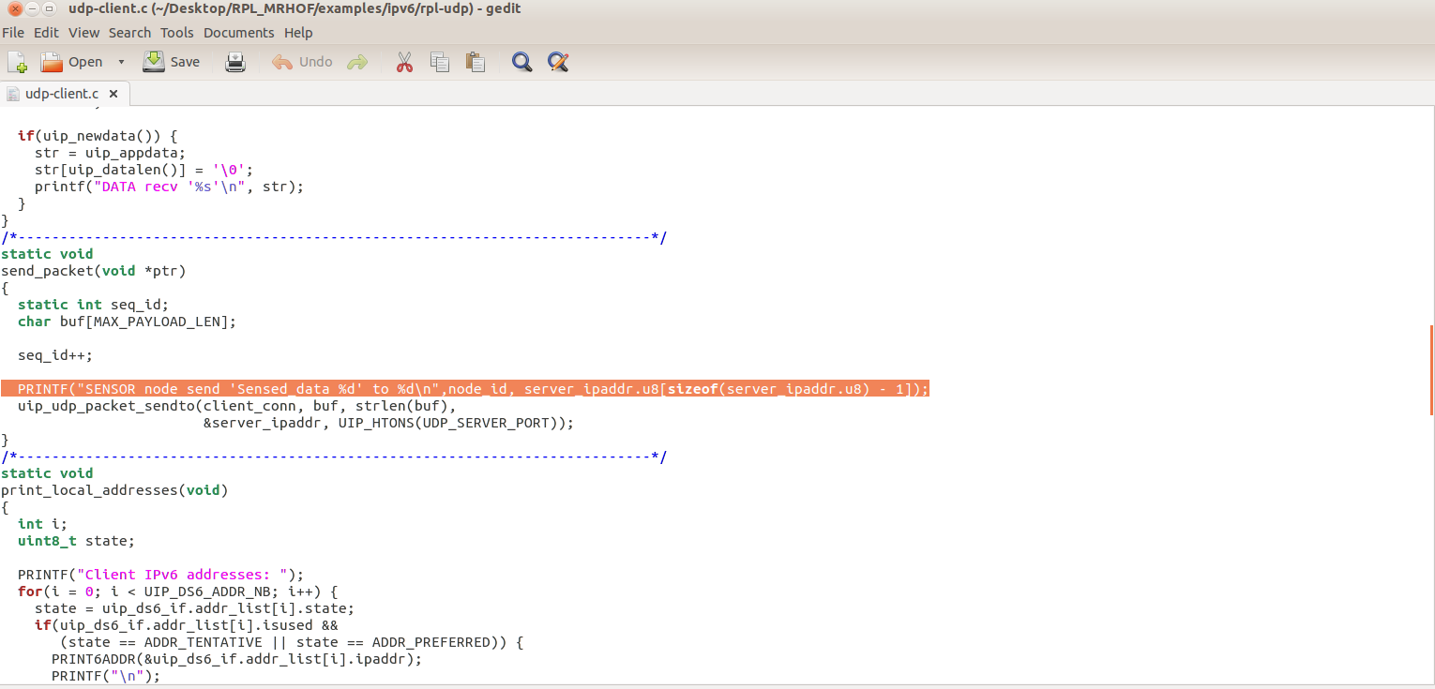

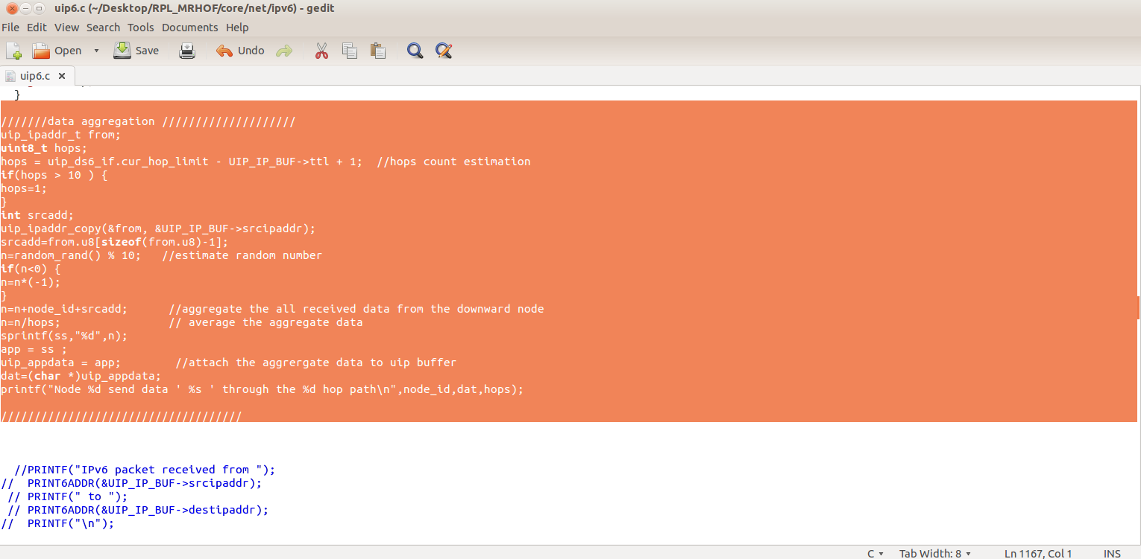

**DATA RECEIVE(udp-server.c)**

Server node will receive all data packets from sensor nodes.

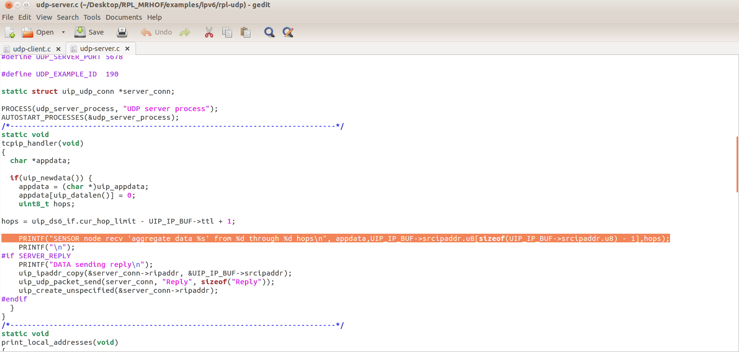

**Performance metrics:**

1. **Packet delivery ratio**

The ratio between total sent packets to the total received packets.

1. **Delay**

It is the time taken between total received time to the total sent time.

**3.Energy Consumption**

Energy consumption is the amount of energy or power used to transmit or receive data packets.